Plan View

186 m

0 m

320 m

FBP X

FBP Y

FBP Z

FCS X

FCS Y

FCS Z

Fire line

Road

320 m

160 m

300 m

250 m

150 m

100 m

50 m

Devices

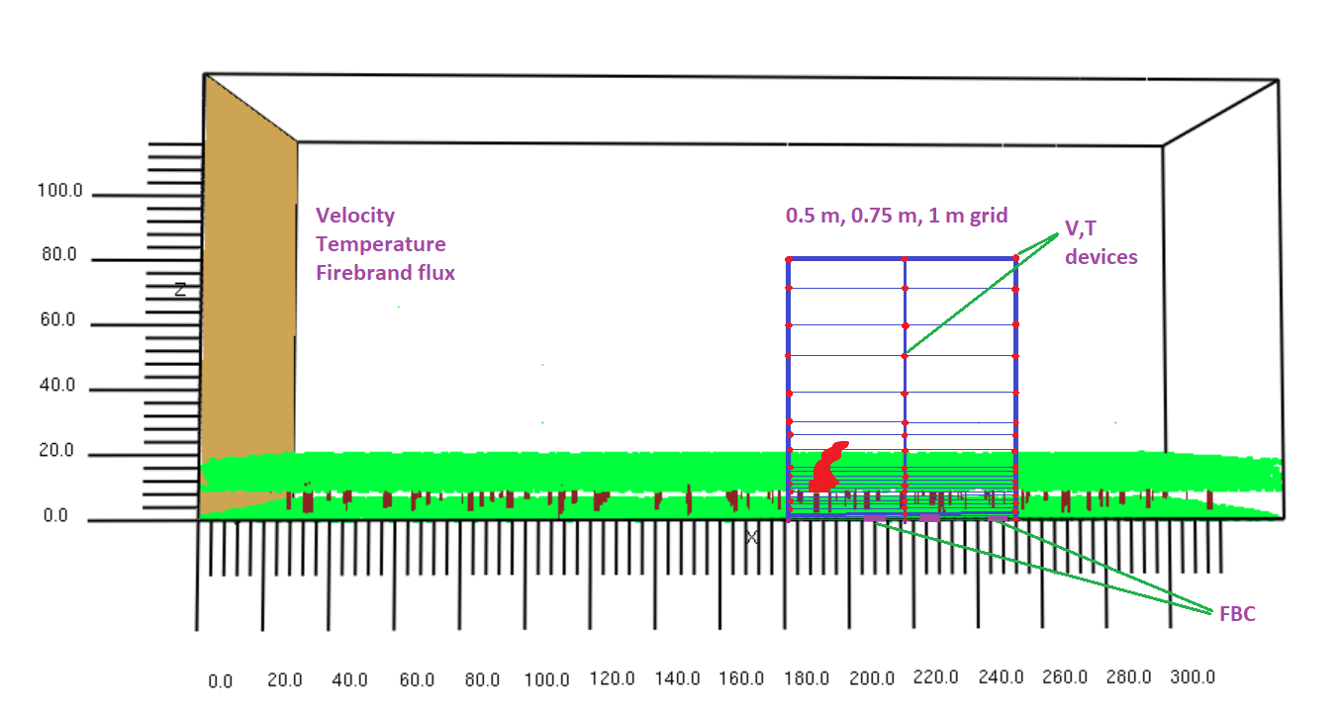

1. Graphical comparison of time-averaged temperature data

|  |
| --- |
|  |

**\*\*MATLAB plotting will be done for different locations.**

|  |
| --- |
|  |
|  |

**Fireline is at x= 186 m

1. Graphical comparison of time series temperature data

|  |
| --- |
| X= 182 m |
| X= 217 m |
| X= 252 m |

1. GCI based on time-series temperature data

|  |  |  |  |  |  |  |
| --- | --- | --- | --- | --- | --- | --- |
|  | GCI (0.75/0. 50) | | | GCI (1.00/0.75) | | |
| Height (m) | x=182 m | x=217 m | x=252 m | x=182 m | x=217 m | x=252 m |
| 0 | 15.2 | 17.8 | 14.0 | 35.4 | 42.4 | 24.6 |
| 5 | 27.63 | 82.0 | 8.3 | 12.4 | 51.8 | 14.2 |
| 10 | 11.44 | 154.6 | 18.7 | 19.6 | 340.8 | 21.5 |
| 15 | 20.79 | 174.3 | 33.6 | 33.1 | 309.0 | 133.1 |
| 20 | 9.40 | 214.1 | 44.5 | 20.3 | 525.2 | 99.4 |
| 30 | 8.03 | 681.0 | 93.8 | 10.4 | 955.7 | 128.3 |
| 40 | 9.57 | 792.7 | 352.2 | 5.9 | 1151.3 | 180.2 |
| 50 | 12.26 | 146.4 | 371.4 | 2.5 | 764.8 | 282.8 |
| 60 | 3.25 | 197.1 | 213.1 | 2.9 | 132.5 | 696.4 |
| 70 | 3.39 | 4.3 | 269.5 | 3.4 | 2.2 | 529.1 |
| 80 | 16.54 | 13.6 | 217.2 | 1.3 | 1.4 | 561.4 |

**Fire line height is 9 m above the ground

|  |
| --- |
|  |

1. GCI based on time-averaged temperature data

|  |  |  |  |  |  |
| --- | --- | --- | --- | --- | --- |
| Єrms | | | **GCI (0.50/0.75)** | | |
| x=182 m | x= 217 m | x=252 m | x=182 m | x= 217 m | x=252 m |
| 0.053975 | 2.316011 | 0.079631 | 13.7 | 38.2 | 26.8 |

|  |  |  |  |  |  |
| --- | --- | --- | --- | --- | --- |
| Єrms | | | **GCI (0.75/1.00)** | | |
| x=182 m | x= 217 m | x=252 m | x=182 m | x= 217 m | x=252 m |
| 0.039417 | 0.243196 | 0.085645 | 16.2 | 53.0 | 30.4 |

**\*\*Currently doing the MATLAB plotting for different locations.**

Firebrand flux

|  |  |  |  |
| --- | --- | --- | --- |
| location | Firebrand flux (pcs/m2.s) | | Difference (%) |
| Grid 750 mm | Grid 1000 mm |
| FCS X | 0.0302 | 0.0395 | 23.5 |
| FCS Y | 0.2732 | 0.5149 | 46.9 |
| FCS Z | 0.9921 | 0.7552 | 23.8 |

Velocity profile at Y=0, after initiating fire

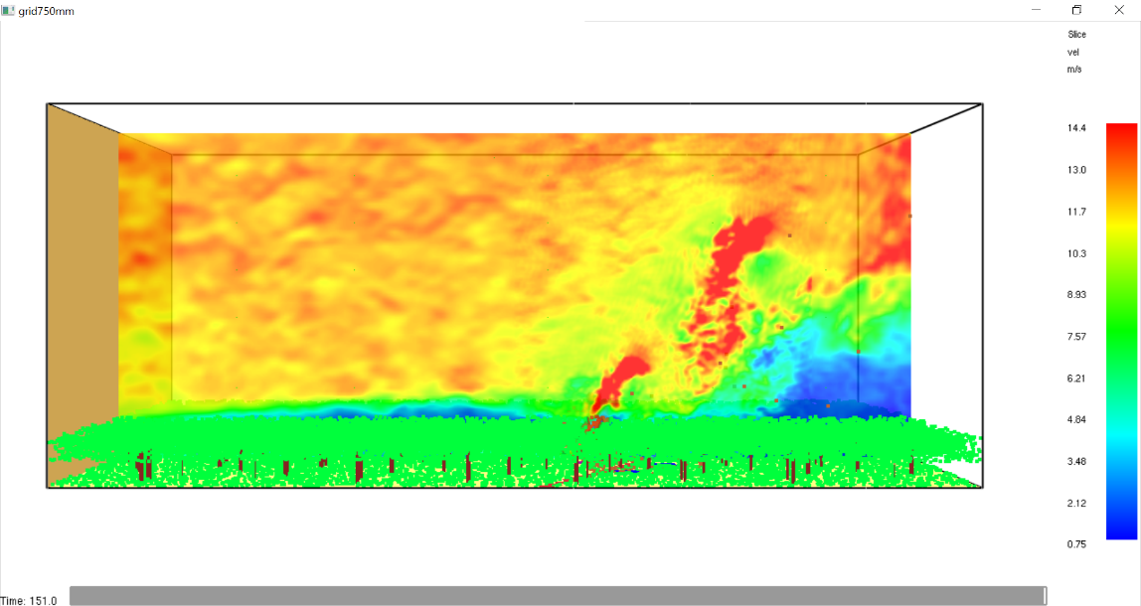

1. Graphical comparison of time-averaged temperature data

750 mm grid

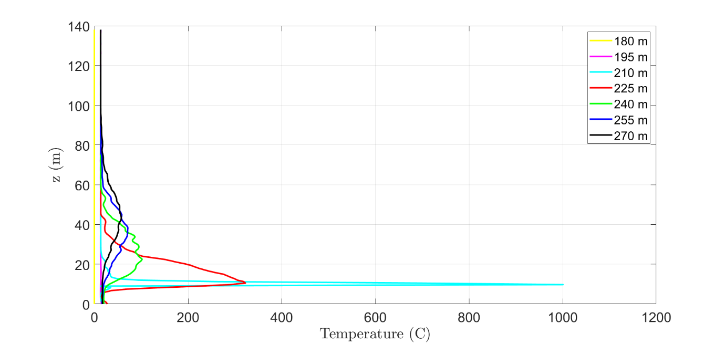

1000 mm grid

